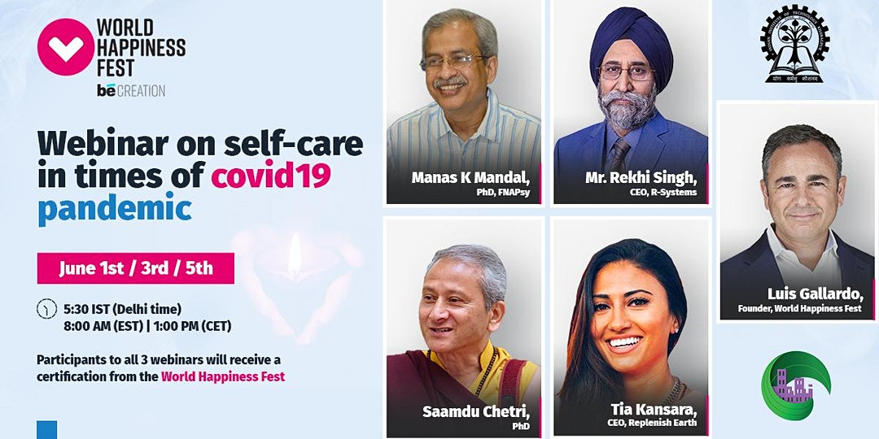
MULTIPLE DATES

WEBINARS ON SELF-CARE IN TIMES OF COVID19 PANDEMIC - Rekhi Centre, IITKGP
by World Happiness Foundation
Follow
Free

WEBINAR SERIES ON SELF-CARE IN TIMES OF COVID19 PANDEMIC with Thought Leaders from the Indian Institute of Technology Kharagpur

About this Event
World Happiness Fest will recognize with a certificate of participation to all those participants that register and attend/watch recorded all 3 sessions.
---
The pandemic of COVID-19 has brought with it uncertainty. It is normal to feel stress and experience anxiety during uncertainty. The ongoing lockdown to prevent the spread of the virus has left us confined in our homes. This can be best utilized by taking a pause and connecting with oneself and others. Self-care is something that is ignored by most of us. This webinar series has been planned to addresses these issues.
Hosted by Luis Gallardo, Founder of the World Happiness Fest, the first speaker of the series Mr. Rekhi would be addressing the issues related to spirituality and awe during this anxiety pandemic. Dr. Chetri would familiarize the participants with the technique of mindfulness to know oneself better.
The next in the series would be a talk by Prof. Mandal addressing the issues related to changing lifestyle and mental health. Issues related to the immersive experience of wellness by staying at home would be addressed by Dr. Kansara.
The series has been coordinated by Dr. Tanusree Dutta Associate Professor in Indian Institute of Technology, Kharagpur and Prof. Priyadarshi Patnaik, Head, Rekhi Centre.
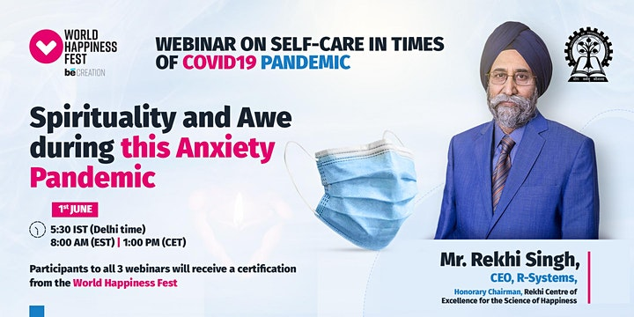
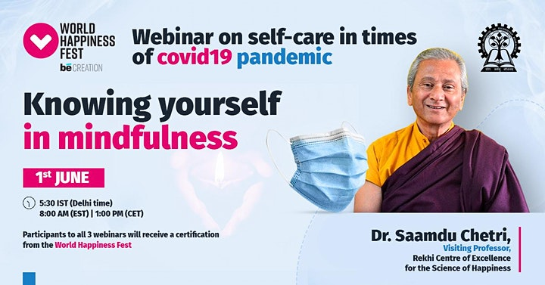
Session 1: June 1st @ 5:30 IST
Spirituality, Awe and Knowing Yourself in Mindfulness.
Mr. Rekhi Singh, CEO, R-Systems, Honorary Chairman, Rekhi Centre of Excellence for the Science of Happiness.
Nothing changes but everything is different if we arise our observing self where there is acceptance and peace with reality. Awe can take us not only to understanding the true self but beyond in experiencing spiritual awakening. What is within you is neither described by what is outside of you nor your own form. The awe helps us to awaken from our sleep. It is special as it can help us arise and create love all around us. Thus, the question asked is can coronavirus be an awe experience for us?
Dr. Saamdu Chetri, Visiting Professor, Rekhi Centre of Excellence for the Science of Happiness
The spiritual journey continues from Mr Rekhi with finding the true self in interdependence, realizing we are not different from one another - to help us awaken and realize the vastness - the Awe as shared by Mr. Rekhi. Knowing the self in mindfulness gives us a deeper understanding of who we are - and grapples to awaken in a question, are we as spiritual as we think? Can mindfulness lead us to Awe that ultimately aims at self-realization or awakening. We will experience an inter-being compassion meditation of about 10 min after the talk.
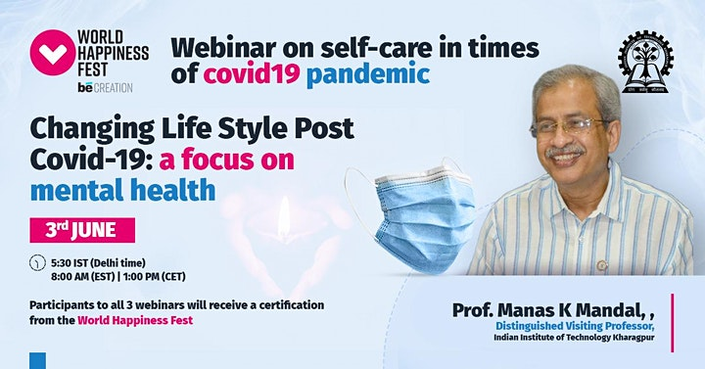
Session 2: June 3rd @ 5:30 IST
Changing Life Style Post COVID-19: a focus on mental health
Prof. Manas K Mandal, Distinguished Visiting Professor, Indian Institute of Technology Kharagpur
Post COVID-19, human behavior has changed significantly across the globe. While life style has changed our day to day functions, the change in coping style has created deep impact in our inner world. This talk will highlight the nature of such change in our life and career with inputs dealing with as to why we resist change, how can we adapt, along with a possible framework for tomorrow to get rid of this impact.
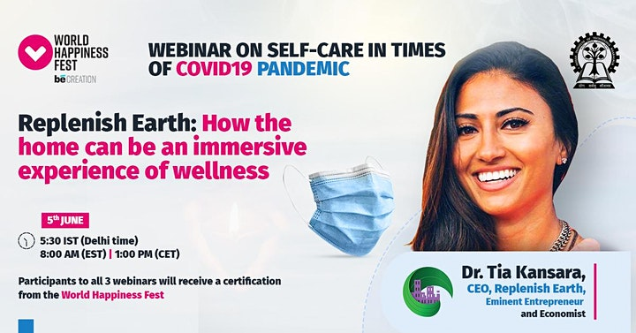
Session 3: June 5th @ 5:30 IST
Replenish Earth: How the home can be an immersive experience of wellness.
Dr. Tia Kansara, Eminent Entrepreneur and Economist
Wellness during COVID-19 is linked to our health and wellbeing indoors. How does the built environment affect our mental, emotional and physical health? In this exciting talk, Dr Kansara will cover the important aspects of being indoors and how to make the most of the time inside. She will delve into how the indoor environment is linked to our noetic evolution adapting over centuries to our physical surroundings. Rooms, buildings and cities are the multi-sensory environments that create epigenetic shifts. Join us in exploring what this means for you.

